
Professional Style Guide: tip sheet

Building a versatile, polished, confident wardrobe



THE BASICS

ASK “WHERE?” AND “WHEN?” BEFORE
“WHAT TO WEAR?”
Before choosing an outfit consider:
- Where am I going? (office, conference, client meeting, presentation, networking event, interview)
- When am I going? (time of day, season,
special occasion)
The setting and purpose should guide your
clothing choices more than any fashion trend.

BUILD WARDROBE USING “BASE COLORS” LIKE BLACK, CREAM/WHITE, GRAY, AND NAVY
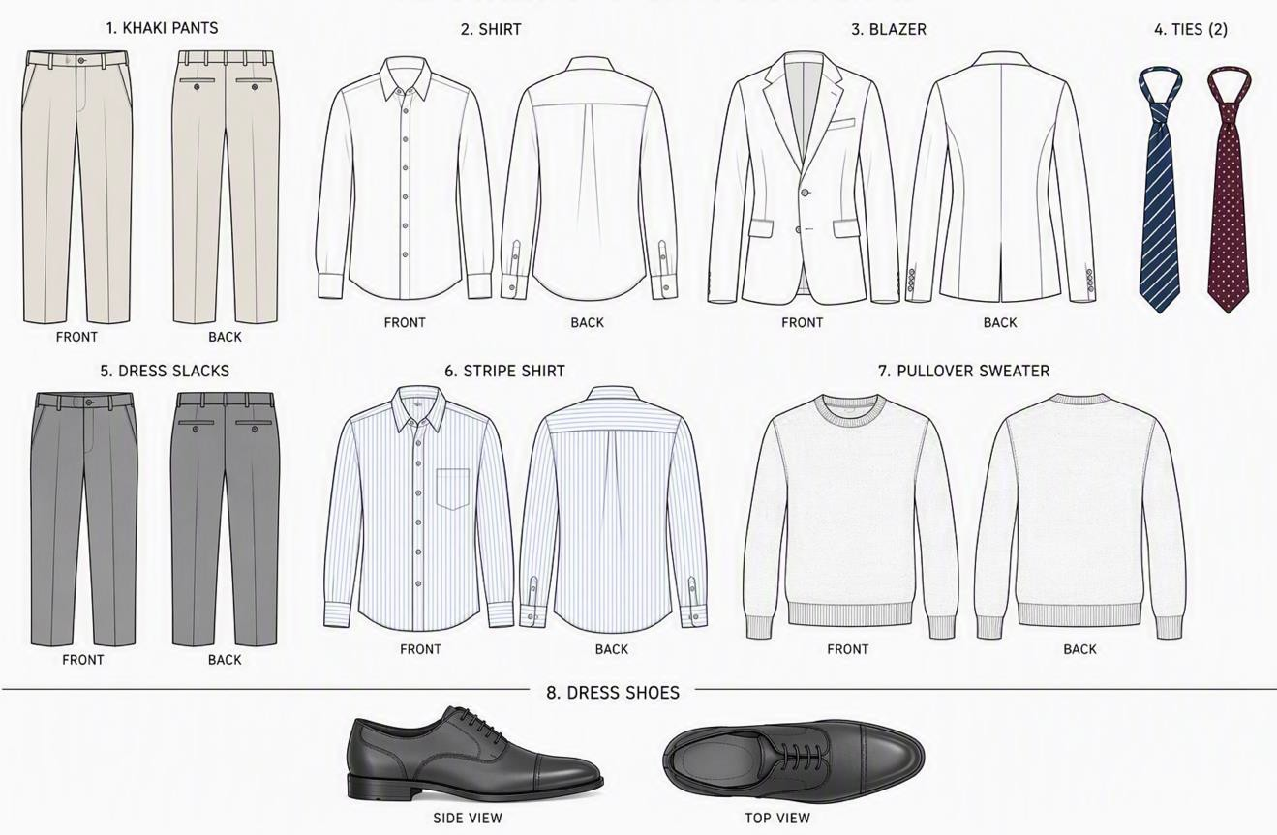
- These colors pair easily with each other and with accent colors, allowing you to
create many professional outfits from fewer pieces

USE THE “3-PIECE RULE” TO CREATE
MORE PULLED TOGETHER LOOKS
- This means having 3 clothing pieces (like a shirt, pants or skirt, and a jacket or sweater).

SAMPLE CAPSULE WARDROBES
Start building your professional look with 7-8 key items
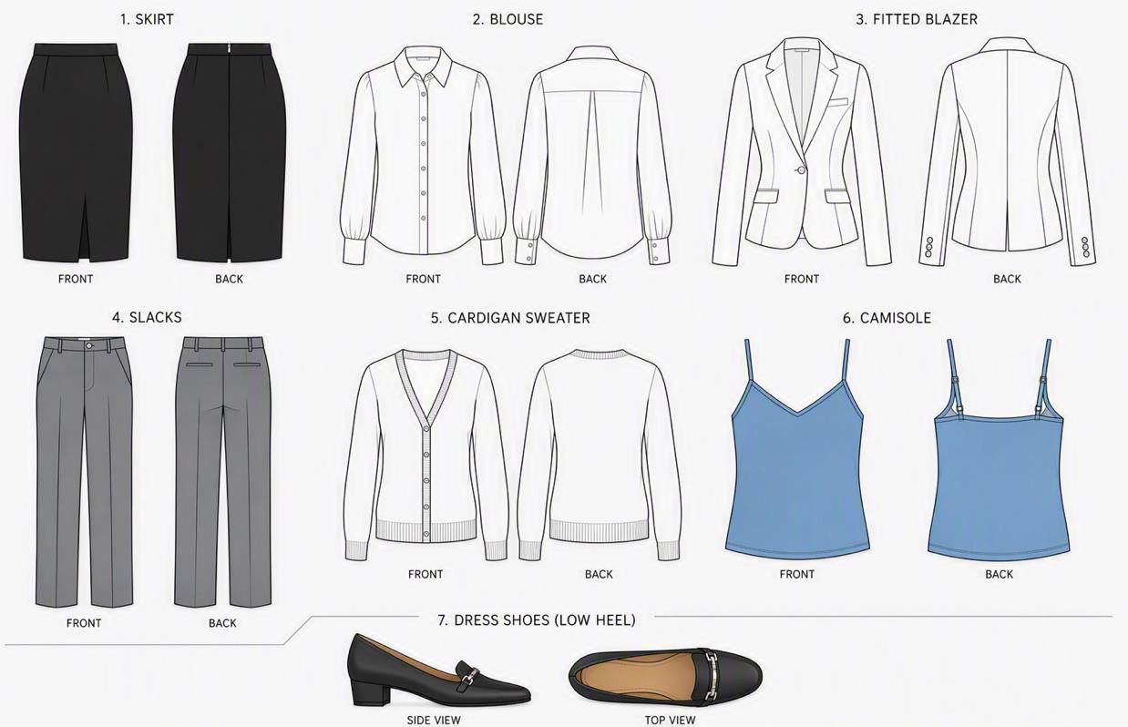

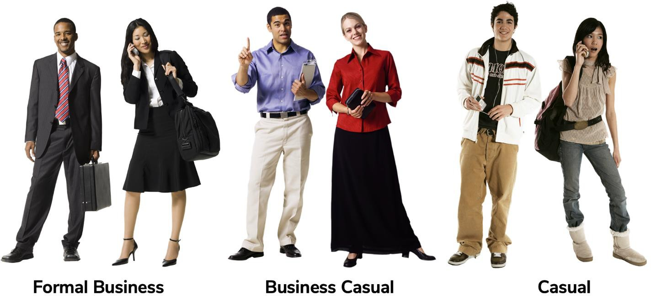
TYPES OF DRESS CODES

